Lab Lex Programs of T Ganesh Phanindra

Exp. No. 21

Write a LEX specification file to take input C program from a .c file and count the number of characters, number of lines & number of words.
Input Source Program: (sample.c)
#include <stdio.h> int main()
{
int number1, number2, sum; printf("Enter two integers: ");
scanf("%d %d", &number1, &number2); sum = number1 + number2;
printf("%d + %d = %d", number1, number2, sum); return 0;
}

Program:
%{
int nchar, nword, nline;
%}
%%
\n { nline++; nchar++; }
[^ \t\n]+ { nword++, nchar += yyleng; }
. { nchar++; }
%%
int yywrap(void) { return 1;
}
int main(int argc, char *argv[]) { yyin = fopen(argv[1], "r"); yylex();
printf("Number of characters = %d\n", nchar); printf("Number of words = %d\n", nword); printf("Number of lines = %d\n", nline); fclose(yyin);
}

Output:

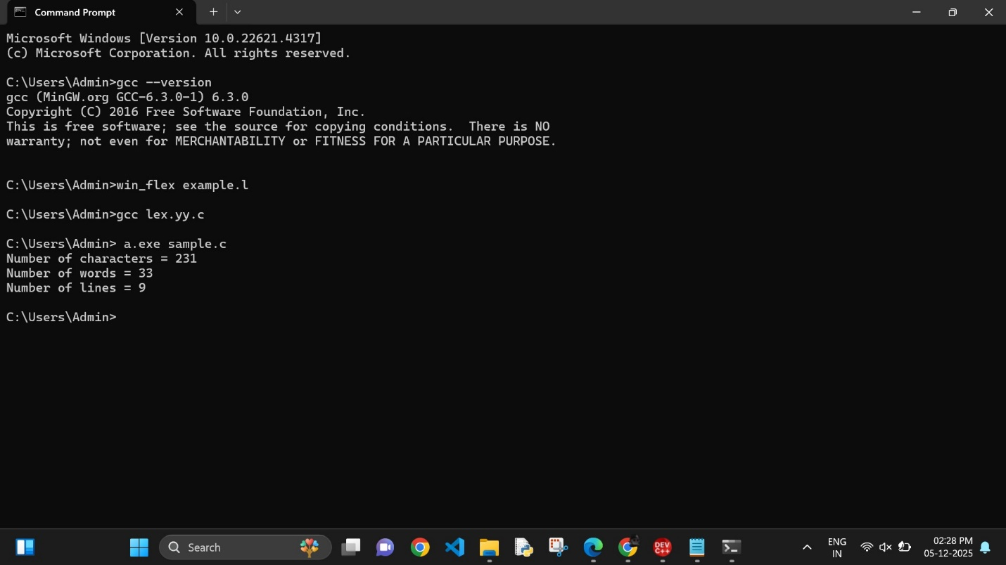

Exp. No. 22

Write a LEX program to print all the constants in the given C source program file.
Input Source Program: (sample.c)
#define P 314 #include<stdio.h> #include<conio.h>
void main()
{
int a,b,c = 30; printf("hello");
}
Program:
digit [0-9]
%{
int cons=0;
%}
%%
{digit}+ { cons++; printf("%s is a constant\n", yytext); }
.|\n { }
%%
int yywrap(void) { return 1; }
int main(void)
{
FILE *f;
char file[10];
printf("Enter File Name : "); scanf("%s",file);
f = fopen(file,"r"); yyin = f;
yylex();
printf("Number of Constants : %d\n", cons); fclose(yyin);
}

Output:
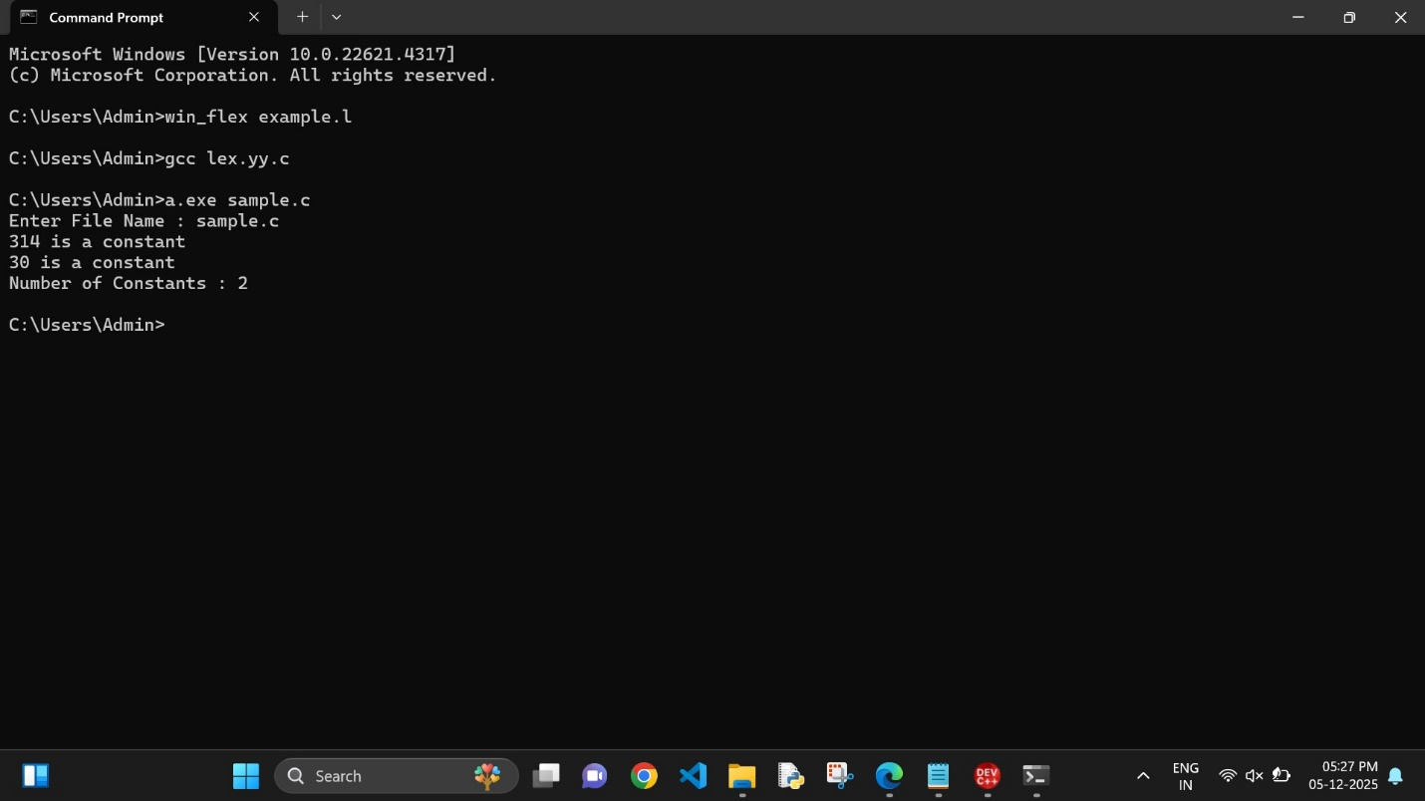

Exp. No. 23

Write a LEX program to count the number of Macros defined and header filesincluded in the C program.
Input Source Program: (sample.c)
#define PI 3.14 #include<stdio.h> #include<conio.h> void main()
{
int a,b,c = 30; printf("hello");
}

Program:
%{
int nmacro, nheader;
%}
%%
^#define { nmacro++; }
^#include { nheader++; }
.|\n { }
%%
int yywrap(void) { return 1;
}
int main(int argc, char *argv[]) { yyin = fopen(argv[1], "r"); yylex();
printf("Number of macros defined = %d\n", nmacro); printf("Number of header files included = %d\n", nheader); fclose(yyin);
}

Output:
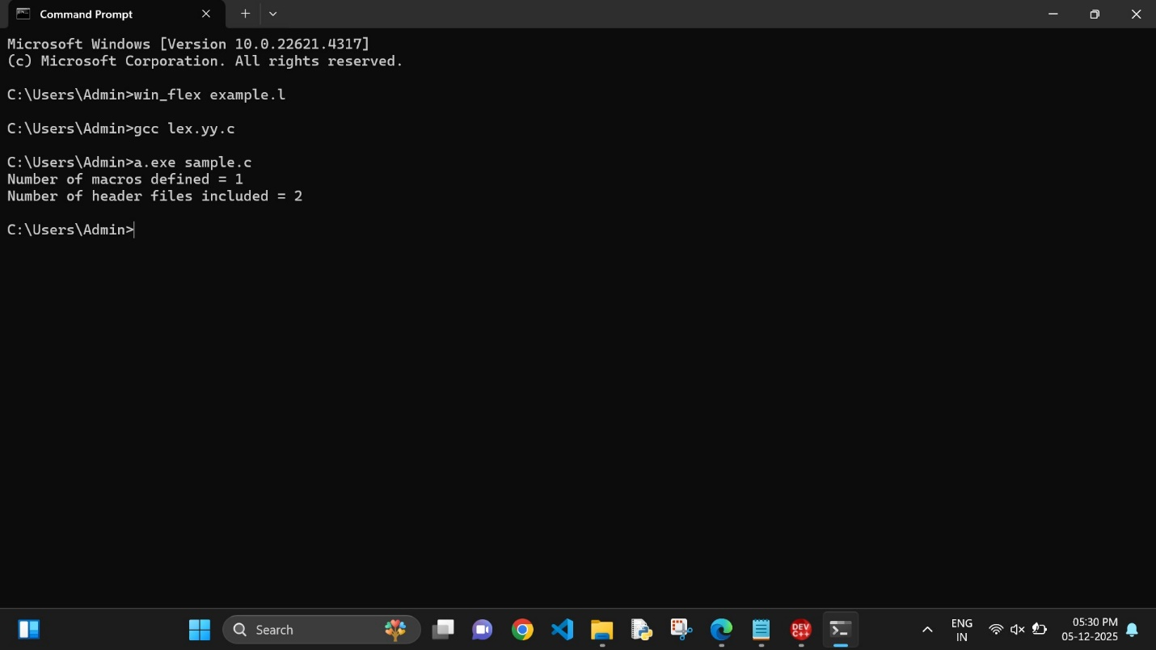

Exp. No. 24

Write a LEX program to print all HTML tags in the input file.
Input Source Program: (sample.html)
<html>
<body>
<h1>My First Heading</h1>
<p>My first paragraph.</p>
</body>
</html>

Program:
%{
int tags;
%}
%%
"<"[^>]*> { tags++; printf("%s \n", yytext); }
.|\n { }
%%
int yywrap(void) { return 1; }
int main(void)
{
FILE *f;
char file[10];
printf("Enter File Name : "); scanf("%s",file);
f = fopen(file,"r"); yyin = f;
yylex();
printf("\n Number of html tags: %d",tags); fclose(yyin);
}

Output: 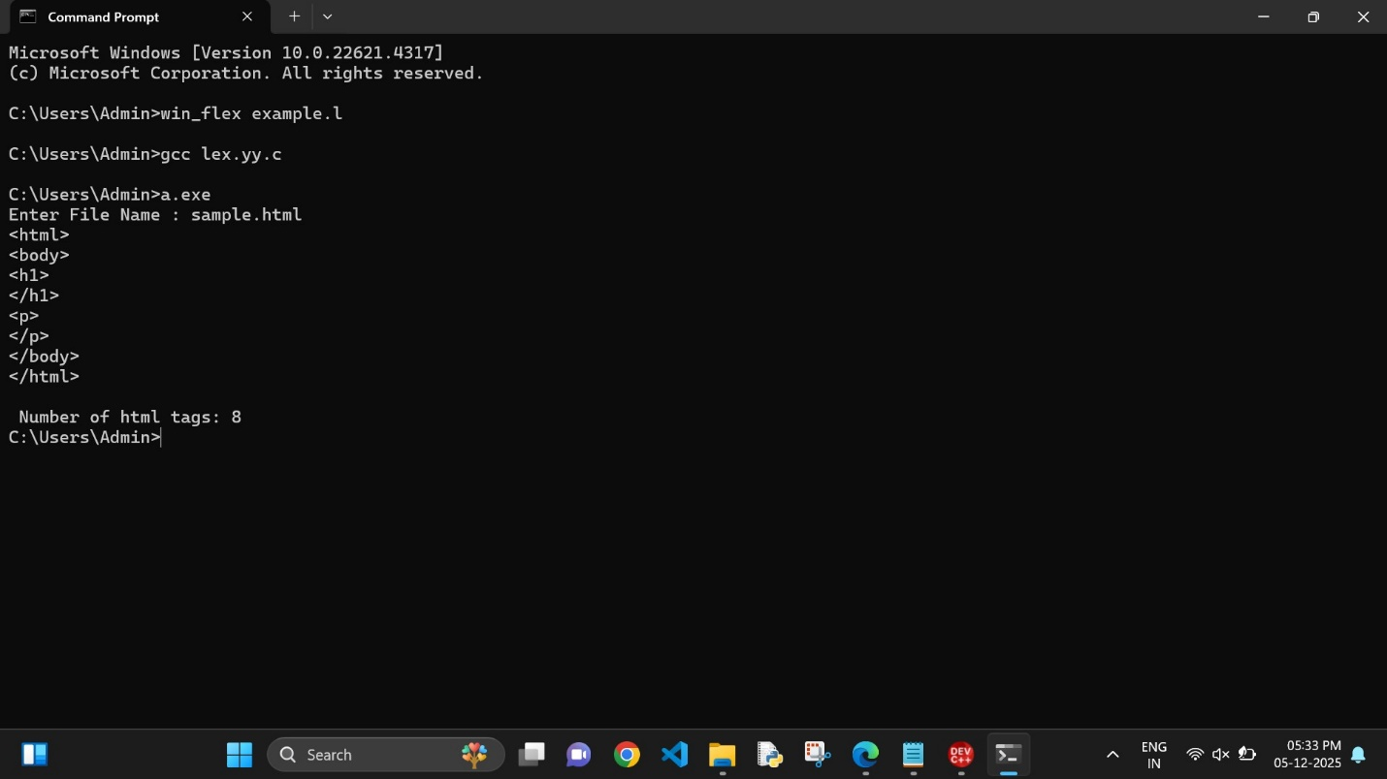

Exp. No. 25

Write a LEX program which adds line numbers to the given C program file and display the same in the standard output.
Input Source Program: (sample.c)
#define PI 3.14 #include<stdio.h> #include<conio.h> void main()
{
int a,b,c = 30;
printf("hello");
}

Program:
%{
int yylineno;
%}
%%
^(.*)\n printf("%4d\t%s", ++yylineno, yytext);
%%
int yywrap(void) { return 1;
}
int main(int argc, char *argv[]) { yyin = fopen(argv[1], "r"); yylex();
fclose(yyin);
}

Output:

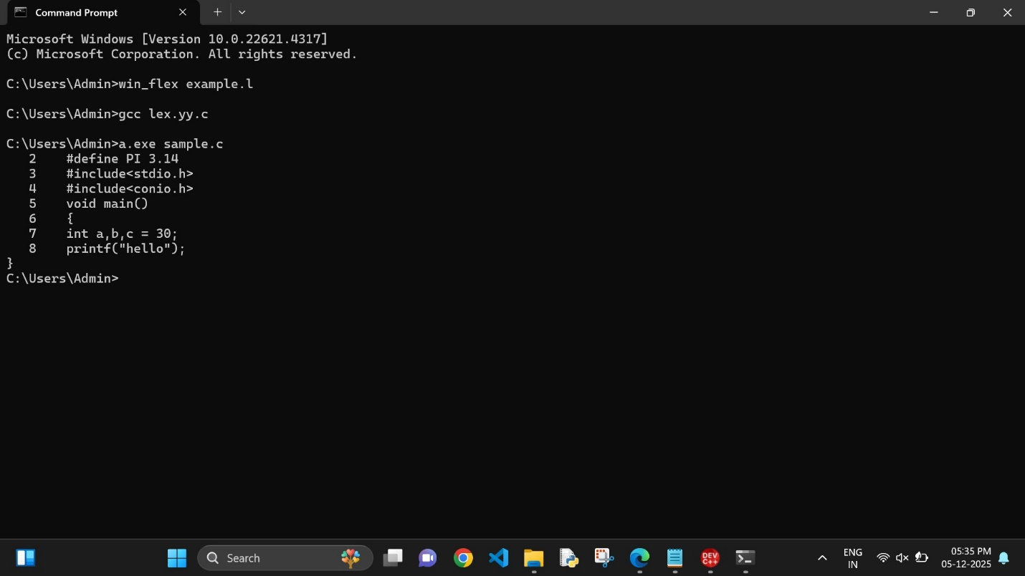

Exp. No. 26

Write a LEX program to count the number of comment lines in a given C program and eliminate them and write into another file.
Input Source File: (input.c)
#include<stdio.h> int main()
{
int a,b,c; /*varible declaration*/ printf(“enter two numbers”); scanf(“%d %d”,&a,&b); c=a+b;//adding two numbers printf(“sum is %d”,c);
return 0;
}

Output File: (output.c)
include<stdio.h>
int main()
{
int a,b,c;
printf(“enter two numbers”); scanf(“%d %d”,&a,&b); c=a+b;
printf(“sum is %d”,c); return 0;
}

Program:
%{
int com=0;
%}
%s COMMENT
%%
"/*" {BEGIN COMMENT;}
<COMMENT>"*/" {BEGIN 0; com++;}
<COMMENT>\n {com++;}
<COMMENT>. {;}
\/\/.* {; com++;}
.|\n {fprintf(yyout,"%s",yytext);}
%%
void main(int argc, char *argv[])
{
if(argc!=3)
{
printf("usage : a.exe input.c output.c\n"); exit(0);
}
yyin=fopen(argv[1],"r");
yyout=fopen(argv[2],"w"); yylex();
printf("\n number of comments are = %d\n",com);
}
int yywrap()

{
return 1;
}

Output:
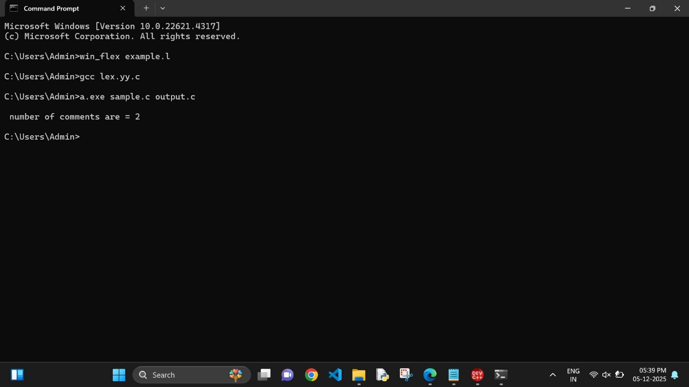

Exp. No. 27

Write a LEX program to identify the capital words from the given input.
Program:
%%
[A-Z]+[\t\n ] { printf("%s is a capital word\n",yytext); }
. ;
%%

int main( )
{
printf("Enter String :\n"); yylex();
}
int yywrap( )
{
return 1;
}

Output:

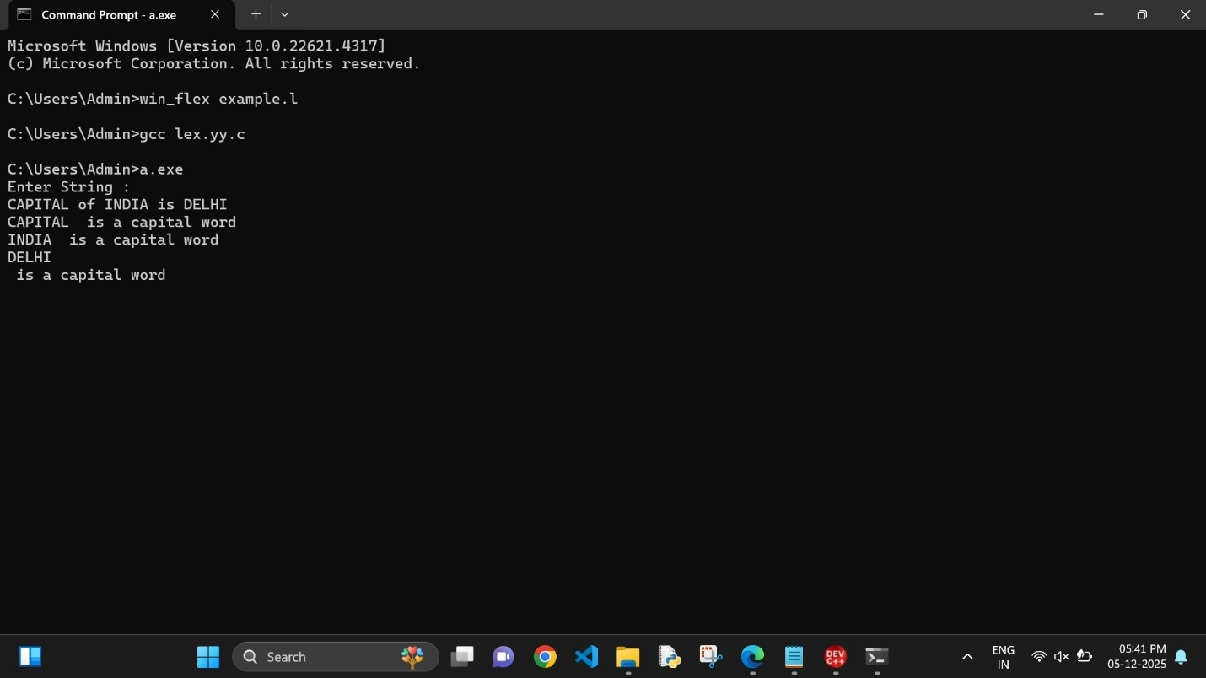

Exp. No. 28

Write a LEX Program to check the email address is valid or not.
Program:
%{
int flag=0;
%}
%%
[a-z . 0-9]+@[a-z]+".com"|".in" { flag=1; }
%%
int main()
{
yylex(); if(flag==1)
printf("Accepted"); else
printf("Not Accepted");
}
int yywrap()
{ return 1;
}

Output:

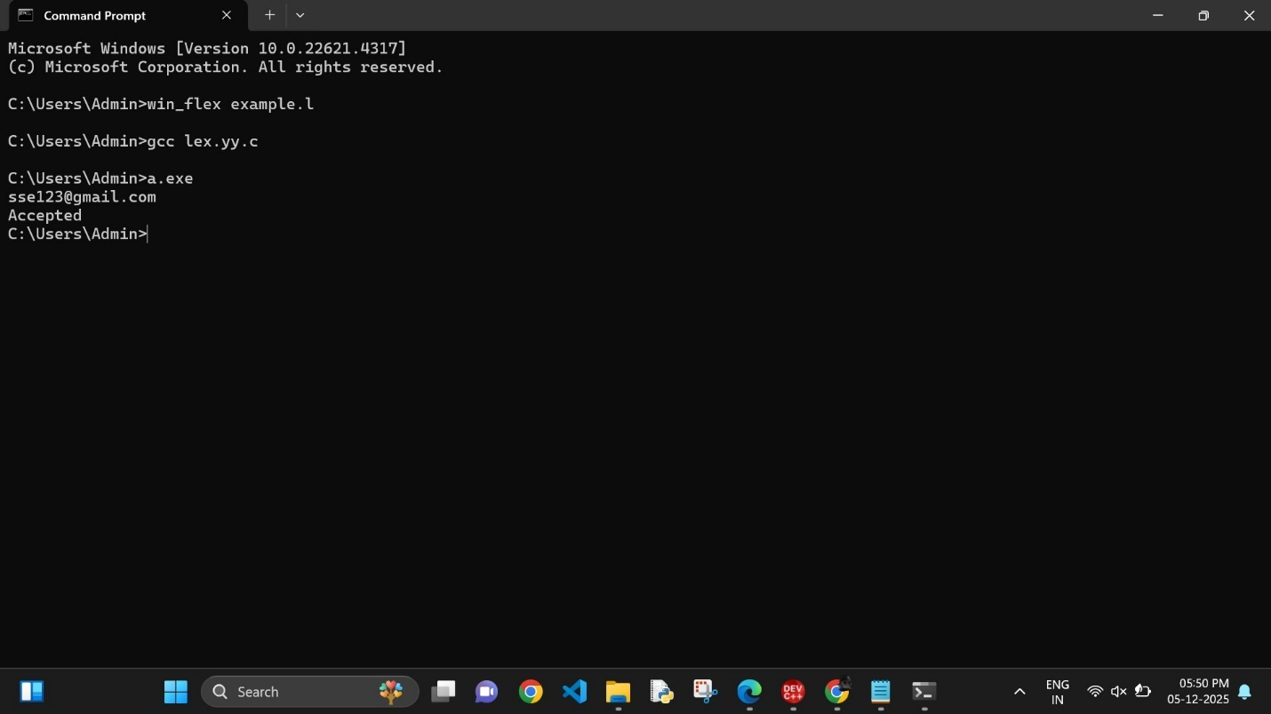

Exp. No. 29

Write a LEX Program to convert the substring abc to ABC from the given input string

Program:
%{
int i;
%}
%%
[a-z A-Z]* { for(i=0;i<=yyleng;i++)
{ if((yytext[i]=='a')&&(yytext[i+1]=='b')&&(yytext[i+2]=='c'))
{ yytext[i]='A';
yytext[i+1]='B';
yytext[i+2]='C';
}
}
printf("%s",yytext);
}

[\t]* return 1;
.* {ECHO;}
\n {printf("%s",yytext);}
%%
int main()
{
yylex();
}
int yywrap()
{
return 1;
}

Output:

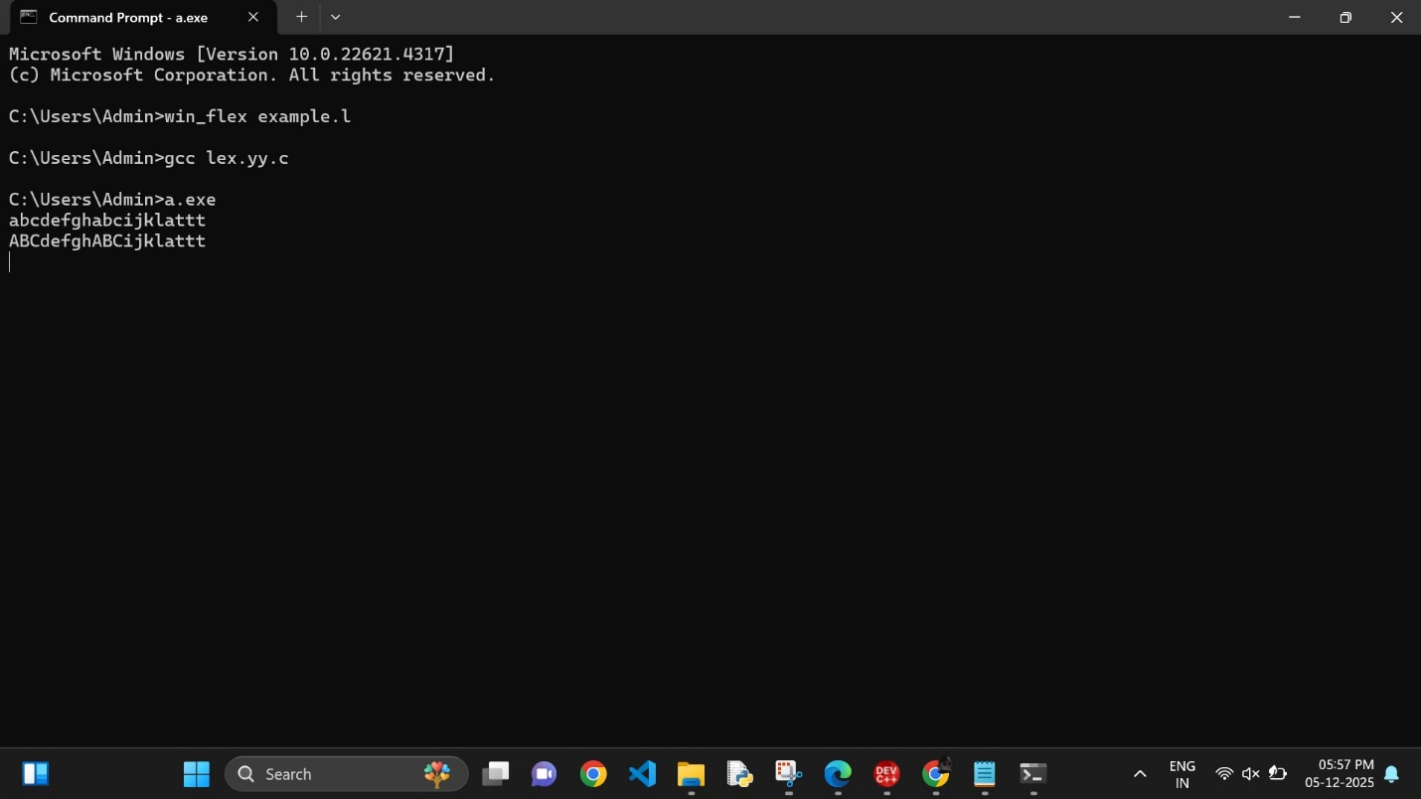

Exp. No. 30

Implement a LEX program to check whether the mobile number is valid or not.
Program:
%%
[1-9][0-9]{9} {printf("\nMobile Number Valid\n");}
.+ {printf("\nMobile Number Invalid\n");}
%%
int main()
{
printf("\nEnter Mobile Number : "); yylex();
printf("\n"); return 0;
}
int yywrap()
{ }

Output:
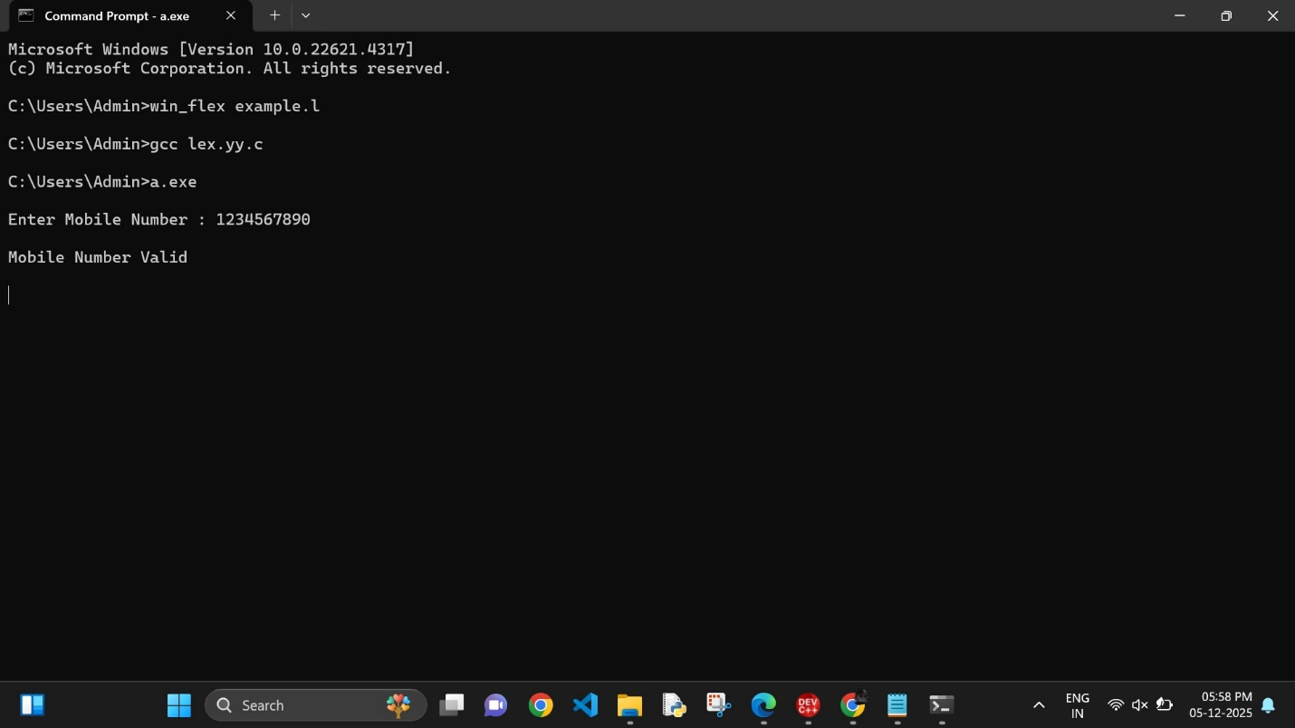

Exp. No. 31

Implement Lexical Analyzer using FLEX (Fast Lexical Analyzer). The program should separate the tokens in the given C program and display with appropriate caption.
Input Source Program: (sample.c)
#include<stdio.h>
void main()
{
int a,b,c = 30;
printf("hello");
}

Program:
digit [0-9] letter [A-Za-z]
%{
int count_id,count_key;
%}
%%
(stdio.h|conio.h) { printf("%s is a standard library\n",yytext); } (include|void|main|printf|int) { printf("%s is a keyword\n",yytext); count_key++; }
{letter}({letter}|{digit})* { printf("%s is a identifier\n", yytext); count_id++; }
{digit}+ { printf("%s is a number\n", yytext); }
\"(\\.|[^"\\])*\" { printf("%s is a string literal\n", yytext); }
.|\n { }
%%
int yywrap(void) { return 1;
}
int main(int argc, char *argv[]) { yyin = fopen(argv[1], "r"); yylex();
printf("number of identifiers = %d\n", count_id); printf("number of keywords = %d\n", count_key); fclose(yyin);
}

Output:
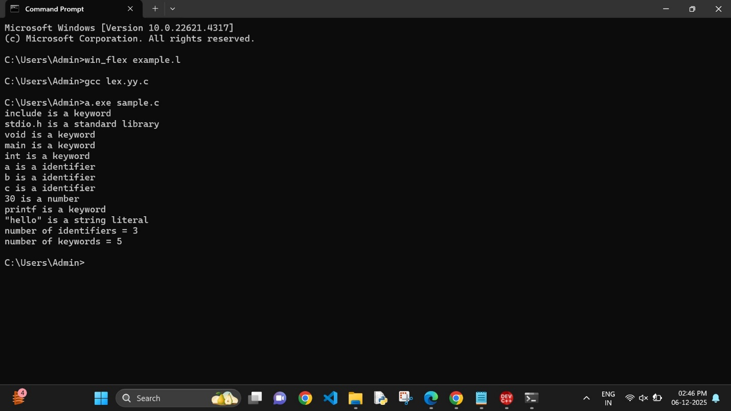

Exp. No. 32

Write a LEX program to count the number of vowels in the given sentence.

Program:
%{
int vow_count=0; int const_count =0;
%}

%%
[aeiouAEIOU] {vow_count++;} [a-zA-Z] {const_count++;}
%%
int yywrap(){} int main()
{
printf("Enter the string of vowels and consonants:"); yylex();
printf("Number of vowels are: %d\n", vow_count); printf("Number of consonants are: %d\n", const_count); return 0;
}

Output:

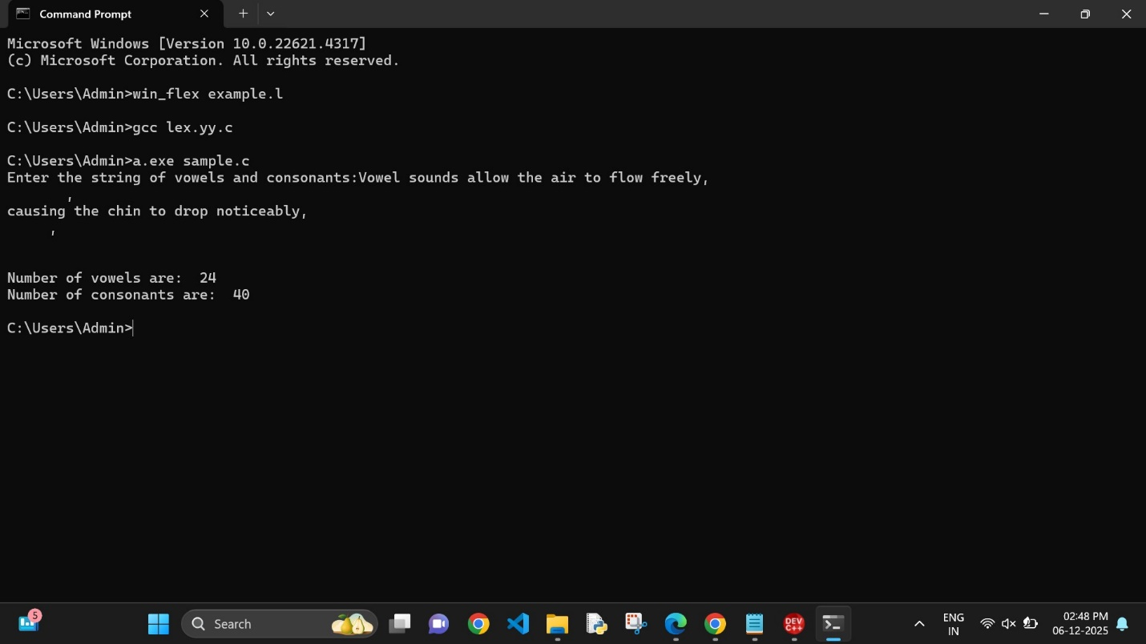

Exp. No. 33

Write a LEX program to count the number of vowels in the given sentence.
Program:
%{
int vow_count=0; int const_count =0;
%}

%%
[aeiouAEIOU] {vow_count++;} [a-zA-Z] {const_count++;}
%%
int yywrap(){} int main()
{
printf("Enter the string of vowels and consonants:"); yylex();
printf("Number of vowels are: %d\n", vow_count); printf("Number of consonants are: %d\n", const_count); return 0;
}

Output:

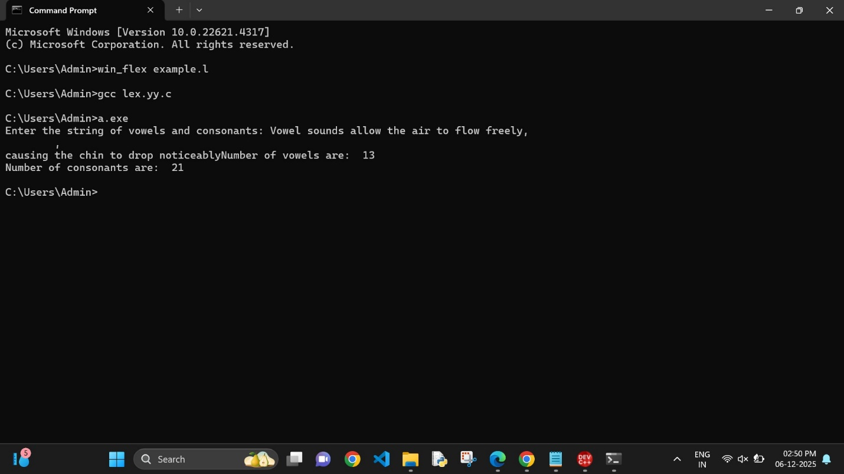

Exp. No. 34

Write a LEX program to separate the keywords and identifiers.
Input Source Program: (sample.c)
#include<stdio.h>
void main()
{
int a,b,c = 30;
printf("hello");
}

Program:
digit [0-9] letter [A-Za-z]
%{
int count_id,count_key;
%}
%%
(stdio.h|conio.h) { printf("%s is a standard library\n",yytext); } (include|void|main|printf|int) { printf("%s is a keyword\n",yytext); count_key++; }
{letter}({letter}|{digit})* { printf("%s is a identifier\n", yytext); count_id++; }
{digit}+ { printf("%s is a number\n", yytext); }
\"(\\.|[^"\\])*\" { printf("%s is a string literal\n", yytext); }
.|\n { }
%%
int yywrap(void) { return 1;
}
int main(int argc, char *argv[]) { yyin = fopen(argv[1], "r"); yylex();
printf("number of identifiers = %d\n", count_id); printf("number of keywords = %d\n", count_key); fclose(yyin);
}

Output:
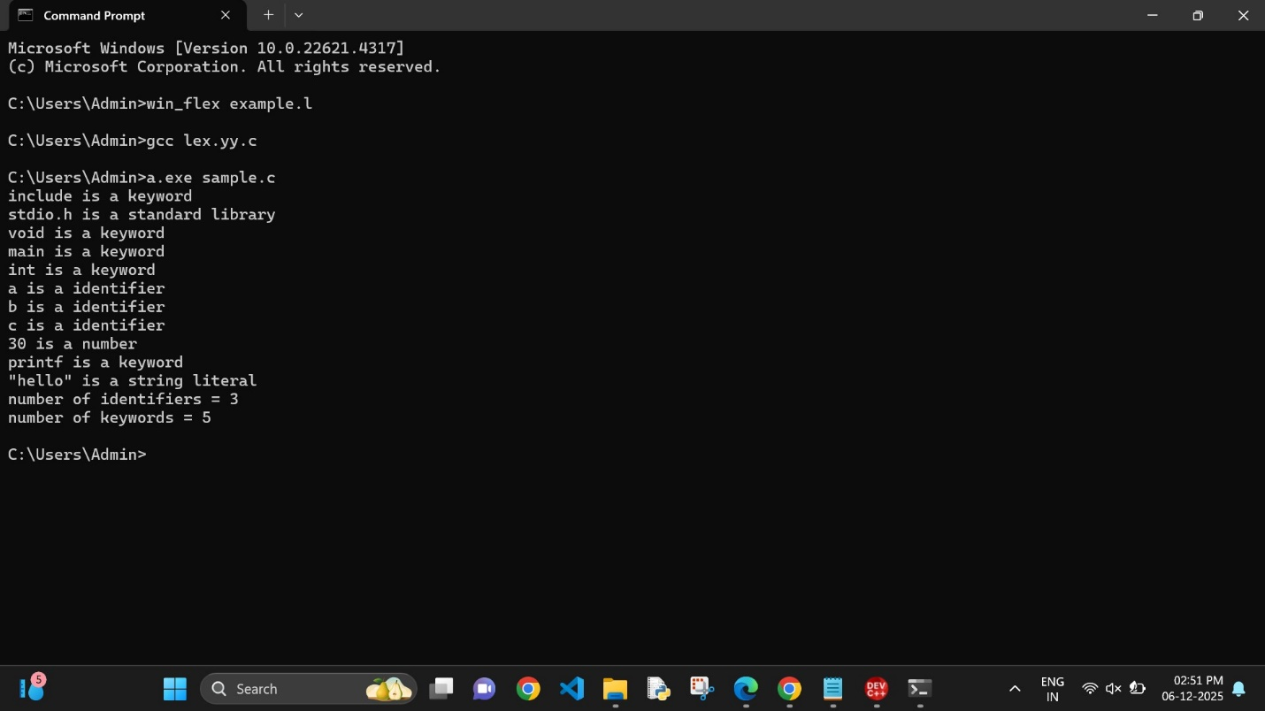

Exp. No. 35

Write a LEX program to recognise numbers and words in a statement.

Program:
%{
#include <stdio.h>
%}
%%
[\t ]+ ;
[0-9]+|[0-9]*\.[0-9]+ { printf("\n%s is NUMBER", yytext); }
#.* { printf("\n%s is COMMENT", yytext); }
[a-zA-Z]+ { printf("\n%s is WORD", yytext); }
\n { ECHO; }
%%
int main()
{
while (yylex())
;
return 0;
}
int yywrap()
{
return 1;
}

Output:
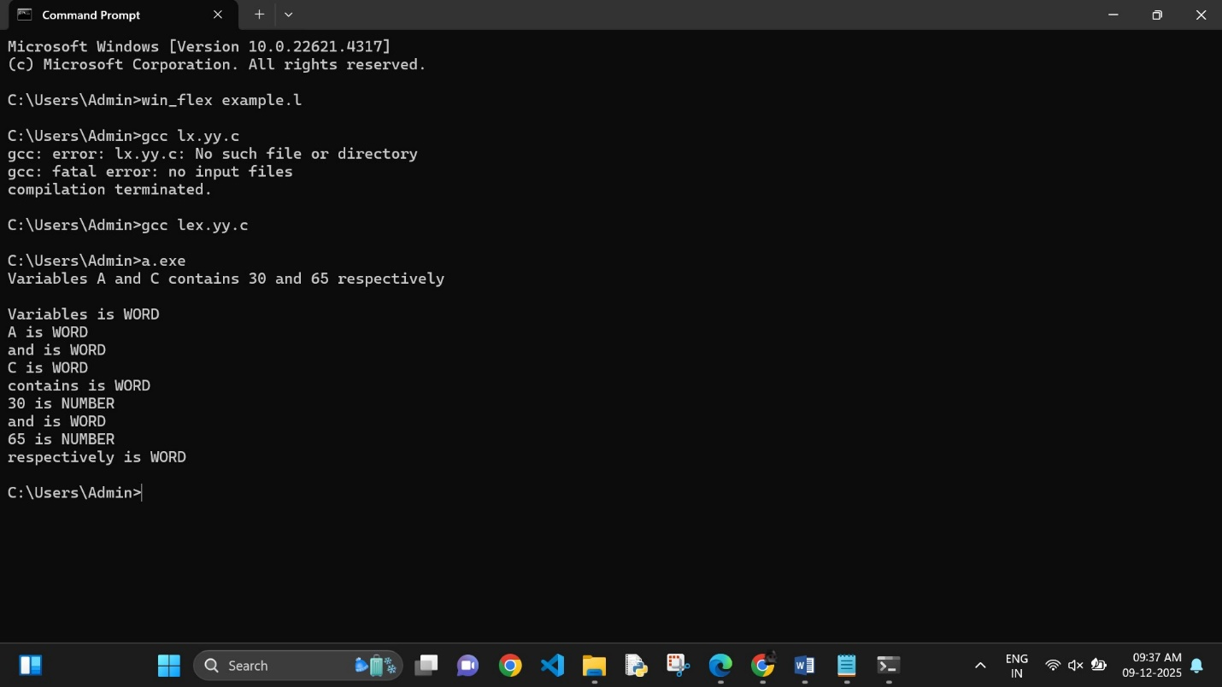

Exp. No. 36

Write a LEX program to identify and count positive and negative numbers.

Program:
%{
int positive_no = 0, negative_no = 0;
%}
%%
^[-][0-9]+ {negative_no++;
printf("negative number = %s\n", yytext);} // negative number

[0-9]+ {positive_no++;
printf("positive number = %s\n",
yytext);} // positive number
%%
int yywrap(){} int main()
{
yylex();
printf ("number of positive numbers = %d,"
"number of negative numbers = %d\n",
positive_no, negative_no);
return 0;
}

Output:

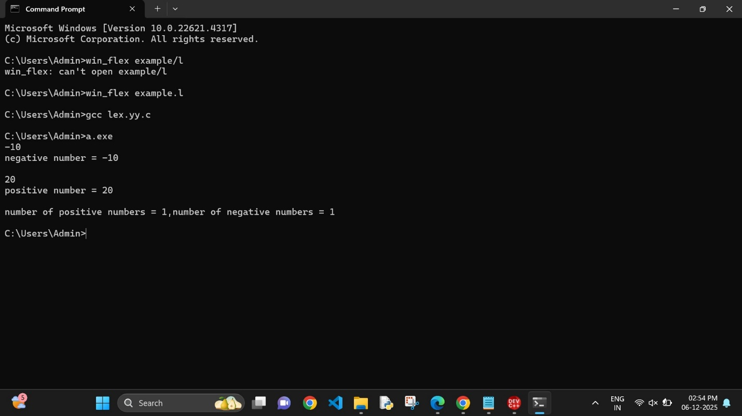

Exp. No. 37

Write a LEX program to validate the URL.

Program:
%%
((http)|(ftp))s?:\/\/[a-zA-Z0-9](.[a-z])+(.[a-zA-Z0-9+=?]*)* {printf("\nURL Valid\n");}

.+ {printf("\nURL Invalid\n");}

%%
void main()
{
printf("\nEnter URL : "); yylex();
printf("\n");
}
int yywrap()
{
}

Output:
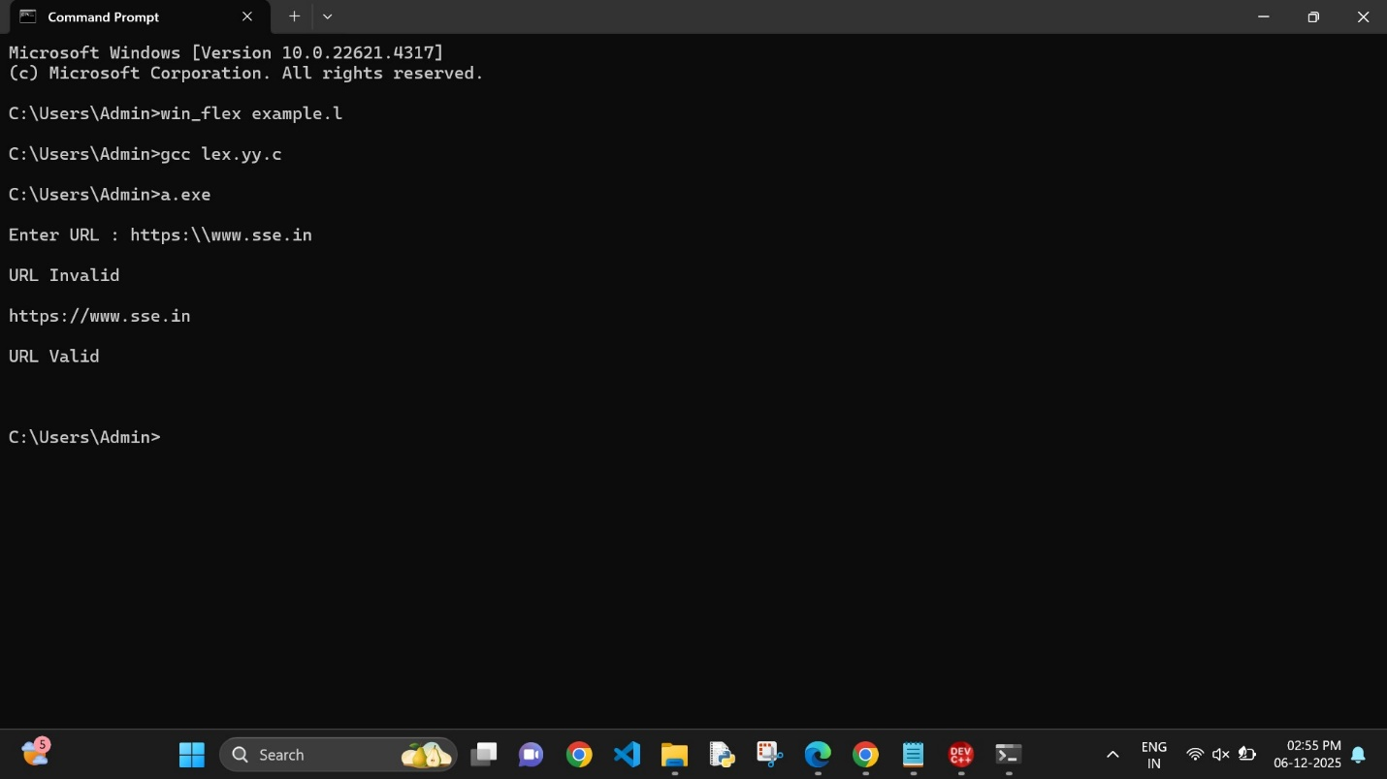

Exp. No. 38

Write a LEX program to validate DOB of students.
Program:
%{
#include <stdio.h>
%}

%%
((0[1-9])|([1-2][0-9])|(3[0-1]))\/((0[1-9])|(1[0-2]))\/(19[0-9]{2}|2[0-9]{3}) { printf("Valid DoB"); }

.* { printf("Invalid DoB"); }
%%

int main()
{
yylex();
return 0;
}
int yywrap()
{
return 1;
}
Output:
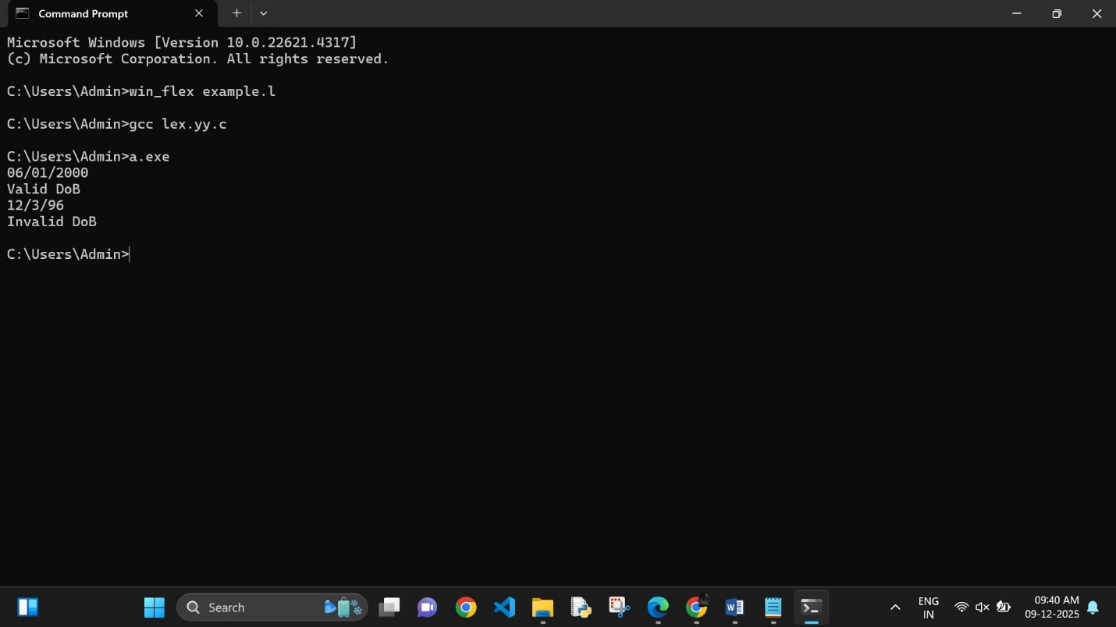

Exp. No. 39

Write a LEX program to check whether the given input is digit or not.
Program:
%%
[0-9]+ {printf("\nValid digit \n");}
.* printf("\nInvalid digit\n");
%%
int yywrap(){} int main()
{
yylex(); return 0;
}

Output:

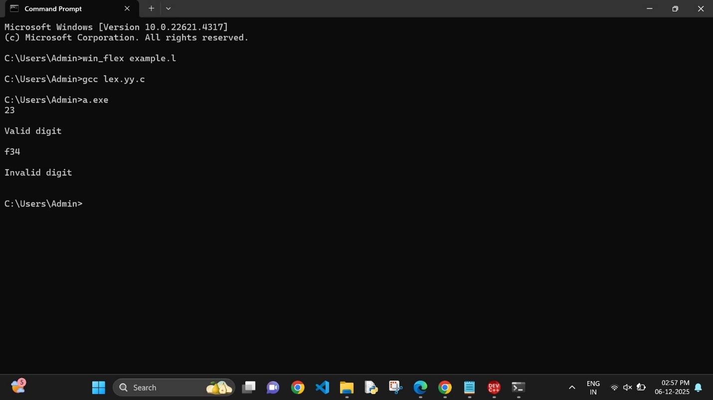

Exp. No. 40

Write a LEX program to implement basic mathematical operations.
Program:
%{
#include <stdio.h>
#include <stdlib.h>

int f1 = 0, f2 = 0;
char oper;
float op1 = 0, op2 = 0, ans = 0;

void eval();
%}

DIGIT [0-9]
NUM {DIGIT}+(\.{DIGIT}+)?
OP [*/+-]

%%
{NUM} {
if (f1 == 0) {
op1 = atof(yytext);
f1 = 1;
}
else if (f2 == -1) {
op2 = atof(yytext);
f2 = 1;
}

if (f1 == 1 && f2 == 1) {
eval();
f1 = 0;
f2 = 0;
}
}

{OP} {
oper = *yytext;
f2 = -1;
}

\n {
if (f1 == 1 && f2 == 1) {
eval();
f1 = 0;
f2 = 0;
}
}
%%

int main()
{
yylex();
return 0;
}

int yywrap()
{
return 1;
}

void eval()
{
switch (oper)
{
case '+': ans = op1 + op2; break;
case '-': ans = op1 - op2; break;
case '*': ans = op1 * op2; break;

case '/':
if (op2 == 0) {
printf("ERROR\n");
return;
}
ans = op1 / op2;
break;

default:
printf("operation not available\n");
return;
}

printf("The answer is = %f\n", ans);
}

Output:
